The team of the UB Faculty of Law won the 2024 René Cassin Advocacy Competition on Human Rights

The team of the Faculty of Law of the University of Bucharest won the 39th edition of the 2024 René Cassin Advocacy Competition on Human Rights, competing against the team of Bruges College of Europe in a final qualified as “phenomenal” by professor Sébastien Touzé, the President of the René Cassin Foundation. The winning team included students Sibel Karacan, Chloé Scholl and Andreea Ivanov, under the coordination of associated professor Carmen Achimescu, PhD, and associated professor Daniela Deteșeanu, PhD. At the same time, student Andreea Ivanov also obtained the individual award for the best plea in the competition.

The 2024 René Cassin Advocacy Competition on Human Rights consists in a simulated process based on the European Convention of Human Rights, on two levels – a written phase and an oral phase, both in French. This year, 32 teams from various countries (Belgium, France, Germany, Romania, Slovenia, Holland and Switzerland) which passed the written phase, participated in the oral phase of the competition. The fictive case elaborated by the Scientific committee of the competition brought forth the necessity of a balanced juridical approach in fields situated at the confluence between freedom of expression, on the one hand, and public morality and artificial intelligence, on the other hand.

The final took place at the European Court of Human Rights in Strasbourg, Friday, March 22nd 2024. The jury comprised judges of the Court, lawyers, teaching staff and representatives of the institutions that are partners in the competition, being presided by Mr. François Sureau, lawyer, writer and member of the French Academy.
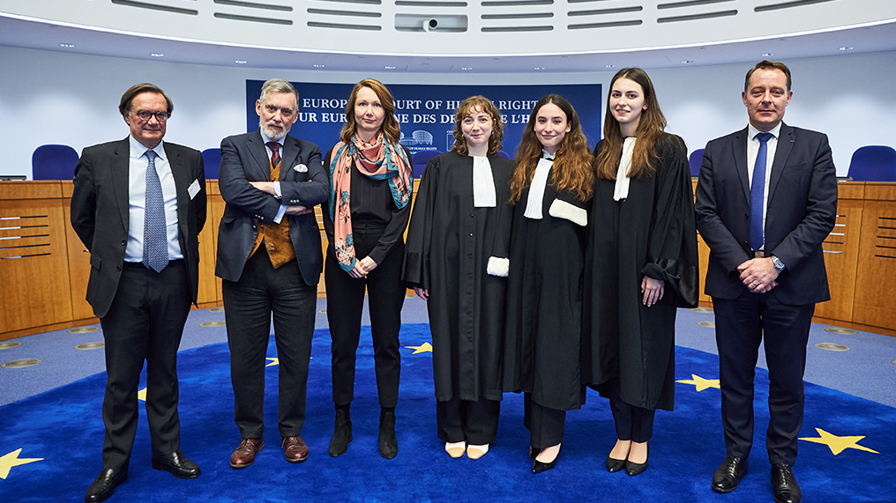
Image taken from the CEDO press-release
https://www.echr.coe.int/w/rene-cassin-competition-2024

