
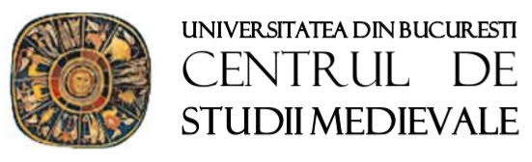

The Medieval and Renaissance Dream
as Experience and Representation
2026 International Conference
of the Centre for Medieval Studies
University of Bucharest
Faculty of Foreign Languages and Literatures
Bucharest, 6-7 November 2026
University Senate Hall, 90-92 Șoseaua Panduri
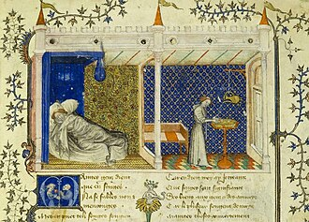

Zoom Connection:
https://us02web.zoom.us/j/83659714975?pwd=UVd3ejBiZlBEVjdDd09XTVhVczV6Zz09
Time: 9:00 a.m. (Romania, Greece)
8:00 a.m. (Italy, Spain, France, Czech Republic, Belgium, Germany, Switzerland)

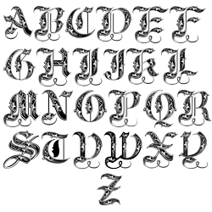
rogramME

Friday 6th November
University Senate Hall
90-92 Șoseaua Panduri
8:30-9:00 Registration
9:00-9:30 Opening address

- 9:30-10:15 Keynote lecture. Chair: Corina Anton
Lavinia Spalanca (Università degli Studi di Palermo) – Ars somniandi. Sogni e visioni nel Rinascimento
10:30-12:00 Session 1. Chair: Manuel Dobre
10:30-10:50 Mihaela Voicu (University of Bucharest) – Les rois rêvent-ils autrement? Rêves royaux et leur élucidation dans le Lancelot en prose (online)
10:50 11:10 Nicola Esposito (Univerzita Palackého v Olomouci) – Il sogno come dispositivo etico e politico nel De casibus virorum ilustrium di Giovanni Boccaccio
11:10-11:30 Valentin Sentis (Université Lumière Lyon 2-CIHAM UMR 5648 CNRS) – Le songeur et ses juges. Rêve, discernement et théologie politique chez Jean Gerson (1401-1429)
11:30-12:00 Q&A session

- 12:00-12:20 Coffee break

- 12:20-13:50 Session 2. Chair: Mianda Cioba
12:20-12:40 Ecaterina Lung (University of Bucharest) – Apparitions, Visions and Dreams in Gregory of Tours’ Works
12:40-13:00 Bogdan Tătaru-Cazaban & Miruna Tătaru-Cazaban (University of Bucharest) – Le rêve dans les Vies de Saint François d’Assise
13:00-13:20 Vassiliki Koutsobina (National and Kapodistrian University of Athens) – The Sounds at the End of the Journey: Sonified Oneiric Narratives From Plato to Dante (online)
13:20-13:50 Q&A session

- 13:50-15:00 Lunch break

- 15:00-16:30 Session 3. Chair: Ioana Gogeanu
15:00-15:20 Federica Maria Giallombardo (Università eCampus Novedrate – Université de Lausanne) – Visioni ed enigmi cinquecenteschi nella Commedia dantesca. Il manoscrito Mediceo Palatino 75
15:20-15:40 Monica Ruset Oancă (University of Bucharest) – The Dream as Mystical Revelation in Pearl
15:40- 16:00 Simona Ilinca Ionescu (University of Bucharest) – “El sueño de la razón produce monstruos”. Lope de Barrientos y el Tractado del dormir et despertar et del soñar (c. 1454)
16:00-16.30 Q&A session

- 16.30-16:50 Coffee break

- 16:50-18:20 Session 4. Chair: Andra Stoiculescu
16:50-17:10 Andreea Popescu (University of Bucharest) – Dream, Initiation, Allegory in William Langland’s Piers Plowman
17:10-17:30 Flavia Palma (Università Ca’ Foscari) – “Parveli in sogno di vedere…”. Sogno, visione e costruzione romanzesca in Urania di Giulia Bigolina (online)
17:30-17:50 Lucía Baudet Rodríguez (Universidad de Jaén) – El sueño como recurso para la sátira en Fantasías de un susto (1630) de Juan Martínez de Moya (online)
17:50-18:20 Q&A session

Saturday 7th November
University Senate Hall
90-92 Șoseaua Panduri

- 10:00-10:45 Keynote lecture. Chair: Ecaterina Lung
- Ioana Gogeanu (University of Bucharest) – Ego dormio et cor meum vigilat. The Moment of Vision in Medieval English Texts

10:55-12.45 Session 5. Chair: Ecaterina Lung
10:55-11:15 Christian Brouwer (Université Libre de Bruxelles) – Théorie et expérience du rêve au Moyen Âge. Saint Augustin et Othloh de Saint Emmeran (vers 1012-vers 1072) (online)
11:15-11:35 Gianluca Lorenzetti (Università degli Studi di Perugia) – Sognare il futuro: visioni oniriche del destino e genitori come destinatari del messaggio profetico. Niccolò V e il De Vita di Giannozzo Manetti (online)
11:35-11:55 Andra Stoiculescu (University of Bucharest) – Whose Dreams are Valid? Authority and Oneiric Interpretation in the Cappadocian Fathers
11:55-12:15 Manuela Dobre (University of Bucharest) – Dreams, Apparitions, and Celestial Signs in 15th century Byzantine historical sources
12:15-12:45 Q&A session

12:45-13:00 Closing remarks

13:00 Lunch

Scientific Committee
Corina Anton (University of Bucharest)
Alvaro Barbieri (Università di Padova)
Lorenzo Bartoli (Universidad Autónoma de Madrid)
Christian Brouwer (Université Libre de Bruxelles)
Mianda Cioba (University of Bucharest)
Cristina Castillo Martinez (Universidad de Jaén)
Ioana Gogeanu (University of Bucharest)
Ecaterina Lung (University of Bucharest)
Lavinia Spalanca (Università degli Studi di Palermo)

